

**PROJECT TITLE:**

**ONLINE CRACKER MANAGEMENT SYSTEM**

**13MSE0414-SATHIYA.G**

**12MSE0349-SASIKALA.T.M**

**Project Report**

**Of**

**SWE503- Software Configuration Management PBL Course**

**Fall 2016-17**

**ABSTRACT**

E-crackers project deals with developing an e-commerce website for online crackers sale. It provides the user with a catalog of different crackers available for purchase in the store. In order to facilitate online purchase a shopping cart is provided to the users. The system is implemented using a three-tier approach with a backend database; a middle tier is WAMP SERVER, PHP and a web browser as the front end client. In order to develop an e-commerce website, a number of technologies must be studied and understood. These include multi-tiered architecture, server and client side scripting techniques, implementation technologies such as programming language (i.e. PHP), relational database (MySQL). This is a project with the objective to develop a website with content management system, where a consumer is provided with a shopping cart application, stock prediction, tracking orders, payments and delivery services.

Content Management System (CMS) is a computer application that allows client to edit, delete, modify, organize and maintain through a central interface.

|  |  |
| --- | --- |
| SERIAL NO | TASK CONTENT |
| 1. | INTRODUCTION |
| 2. | LITERATURE SURVEY |
| 3. | EXISTING SYSTEM AND DRAWBACKS |
| 3.1 | PROPOSED SYSTEM |
| 4 | SYSTEM DESIGN |
| 4.1 | SYSTEM ARCHITECTURE |
| 4.2 | DATA FLOW DIAGRAM |
| 4.3 | ACTIVITY DIAGRAM |
| 4.4 | CLASS DIAGRAM |
| 4.5 | USE CASE DIAGRAM |
| 4.6 | SEQUENCE DIAGRAM |
| 5 | SYSTEM SPECIFICATION |
| 5.1 | HARDWARE SPECIFICATION |
| 5.2 | SOFTWARE SPECIFICATION |
| 6 | SCM ACTIVITIES |
| 6.1 | CONFIGURATION IDENTIFICATION |
| 6.2 | CONFIGURATION CHANGE CONTROL |
| 6.3 | STATUS ACCOUNTING |
| 6.4 | AUDITING AND REVIEW |
| 7 | SCM PLANNING |
| 7.1 | INTRODUCTION |
| 7.2 | SCOPE |
| 7.3 | TERMS AND CONDITIONS |
| 7.4 | CONCESSION |
| 7.5 | CONFIGURATION |
| 7.5.1 | CONFIGURATION BASELINE |
| 7.5.2 | CONFIGURATION MANAGEMENT RESPONSIBILITY |
| 7.6 | INTERFACE |
| 8 | SNAPSHOTS |
| 9 | REFERENCES |

1. **INTRODUCTION**

E-commerce is fast gaining ground as an accepted and used business paradigm. More and more business houses are implementing web site providing functionality for performing commercial transactions over the web. It is reasonable to say that the process of shopping on the web is becoming commonplace. Content Management System provides flexibility for client to easily update their products dynamically which is connected to the database. The benefit of using CMS is, we can change the content without the fear of changing the design. Customer is the user of the system. An administrator of the website is the super user. When the user types in the URL of the website, a Welcome page is shown which has a menu in the bottom, a banner at the top and any related links to other sites. This site contains an online catalog for the user. User has to login to Welcome Page before ordering anything. Login functionality should check the authenticity of the user from the database.

**The problem with existing system,** recommendation is given for all the products based on users browsing items. In our website we are going to provide recommendation for the active users based on the purchasing amount and orders using Data mining concept.

The aim and objective of the proposed system will contain the following activities, which try to automate the entire process keeping in view of the database integration approach.

1. User friendliness is provided in the application with various controls.
2. The system makes the overall project management much easier and flexible.
3. There is no risk of data mismanagement at any level while the project development is under process.
4. **LITERATURE SURVEY:**

The purpose of the study is to broaden the research on online shopping process.

1. Walter Alberto Aldana.” Data Mining Industry: Emerging Trends and New Opportunities”, May 2000.

2.G. Adomavicius and A. Tuzhilin, “Toward the Next Generation of Recommender Systems: A Survey of the State -of-the-Art and Possible Extensions,” IEEE Trans. Knowledge and Data Eng., vol. 17, no. 6, pp. 734 -749, June 2005.

3. Sotiris Kotsiantis, Dimitris Kanellopouios “Association Rules Mining: A RecentOverview” GESTS International Transactions on Computer Science and Engineering, Vol.32 (1), 2006

4. E.W.T. Ngai, Li Xiu and D.C.K. Chau, “Application of data mining techniques in customer relationship management: A literature review and classification” Department of Management and Marketing, The Hong Kong Polytechnic University, Hong Kong, PR China, Department of Automation, Tsinghua University, Beijing, PR China

1. **EXISTING SYSTEM AND DRAWBACKS:**

**1.** Data mining is part of the knowledge discovery process that offers a new way to look at data. Data mining consists of the nontrivial extraction of implicit, previously unknown, and potentially useful information from data.

**2.** This paper presents an overview of the field of recommender systems and describes the current generation of recommendation methods that are usually classified into the following three main categories: content-based, collaborative, and hybrid recommendation approaches

**3**. In this paper, we provide the preliminaries of basic concepts about association rule mining and survey the list of existing association rule mining techniques.

**4.** Despite the importance of data mining techniques to customer relationship management (CRM), there is a lack of a comprehensive literature review and a classification scheme for it. This is the first identifiable academic literature review of the application of data mining techniques to CRM.

**3.1 PROPOSED SYSTEM**:

The aim and objective of the proposed system will contain the following activities, which try to automate the entire process keeping in view of the database integration approach.

1. User friendliness is provided in the application with various controls.
2. The system makes the overall project management much easier and flexible.

There is no risk of data mismanagement at any level while the project development is under process.

1. **SYSTEM DESIGN**
   1. **SYSTEM ARCHITECTURE:**

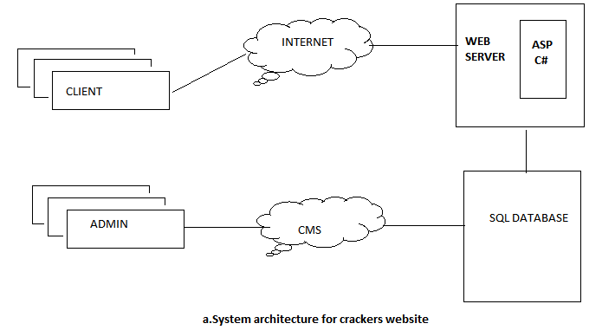

* 1. **DATA FLOW DIAGRAM:**

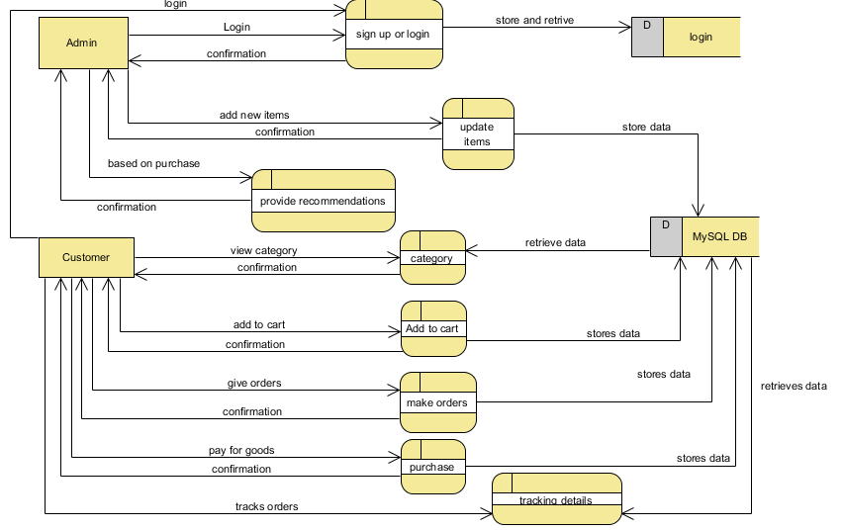

* 1. **ACTIVITY DIAGRAM:**
  2. **CLASS DIAGRAM:**



* 1. **USE CASE DIAGRAM:**



* 1. **SEQUENCE DIAGRAM:**



1. **SYSTEM SPECIFICATION**
   1. **HARDWARE SPECIFICATION**

HARD DISK: 500 gigabyte

RAM: 4 giga bytes

PROCESSOR: intel core i5

* 1. **SOFTWARE SPECIFICATION**

LANGUAGE: PHP

FRONT END: PHP

BACK END: PHP MyAdmin (MySQL)

OS: windows 7, 64 bit processor

1. **SOFTWARE CONFIGURATION ACTIVITIES**
   1. **CONFIGURATION IDENTIFICATION**

* Login (login username, password)
* Sign up page.

**REGISTRATION FORM CONTAINS:**

* First name
* Last name
* Username
* Password
* Confirm password.
* Mobile number.
* Database creation.
  1. **CONFIGURATION CHANGE CONTROL**
* Puts you in a better position to be ready for change.
* Understanding that different characteristics of change need different approaches.
* Helps you implement a process to navigate the required change.
* Builds commitment to work together, to bring people with you.
* Can help with appreciating what is currently done well, so that the future is built on strengths which currently exist within the organization.
* Delivers change those results in real improvements.
* Compatibility.
  1. **CONFIGURATION STATUS ACCOUNTING**
* Control changes to source code and documentation.
* Record the individual making the change.
* Record the date and reason for making the change.
* Provide version description to the unit level.
* Automatically assign new version numbers upon successful compilation of files.
  1. **AUDITING AND REVIEW**

It generates the report whatever we are done in the previous activities.

1. **SOFTWARE CONFIGURATION MANAGEMENT PLANNING**
   1. **INTRODUCTION:**

E-cracker project is a user friendly environment. E-cracker system is a way in which a user has complete freedom in tailoring his crackers the way he/she wishes. It accommodates the wants and needs of the entire user community as a whole.

* 1. **SCOPE:**

E-crackers project deals with developing an e-commerce website for online crackers sale. It provides the user with **a catalog of different crackers available for purchase in the store**. In order to facilitate online purchase a shopping cart is provided to the users.

* 1. **Terms and conditions:**
     1. **Change control:**

The activities for control of the product after formal approval of its **product configuration information.**

* + 1. **Concession:**

The permission to use or release a product that does not conform to specified requirements.

* + - 1. **NOTE 1:**

A concession is generally limited to the delivery of the product that has nonconforming characteristics within specified limits for an agreed time or quantity of that product.

* + - 1. **NOTE 2:**

Concessions do not affect the **configuration baseline** and include permission to produce a product that does not conform to specified requirements.

* + - 1. **NOTE 3:**

Some organizations use terms such as **“waivers” or “deviations”** instead of “concession”.

* 1. **CONFIGURATION:**

The interrelated **functional and physical characteristics** of a product defined in product configuration information.

* + 1. **CONFIGURATION BASELINE:**

The approved product configuration information that **establishes the characteristics of a product** at a point in time that serves as reference for activities throughout the life cycle of the product.

* 1. **CONFIGURATION MANAGEMENT RESPONSIBILITY:**
* The organization should identify and describe responsibilities and authorities related to the implementation and verification of the configuration management process. The following should be considered:
* The complexity and nature of the product;
* The needs of the different product life cycle stages;
* The interfaces between activities directly involved in the configuration management process;
* The other relevant interested parties that may be involved, within and outside the organization.
* The identification of the responsible authority for verifying implementation activities.
* The identification of the dispositioning authority.
  1. **INTERFACE:**

The definition of the interfaces is one of the most **important planning elements** for ensuring a smoothing operation. Every possible effort should be made to reach the common agreement regarding each organization’s responsibility regarding the interface(s) and then document them in the subsection.

1. **SNAPSHOTS**
   1. **HOME PAGE:**



* 1. **PRODUCTS VIEW:**

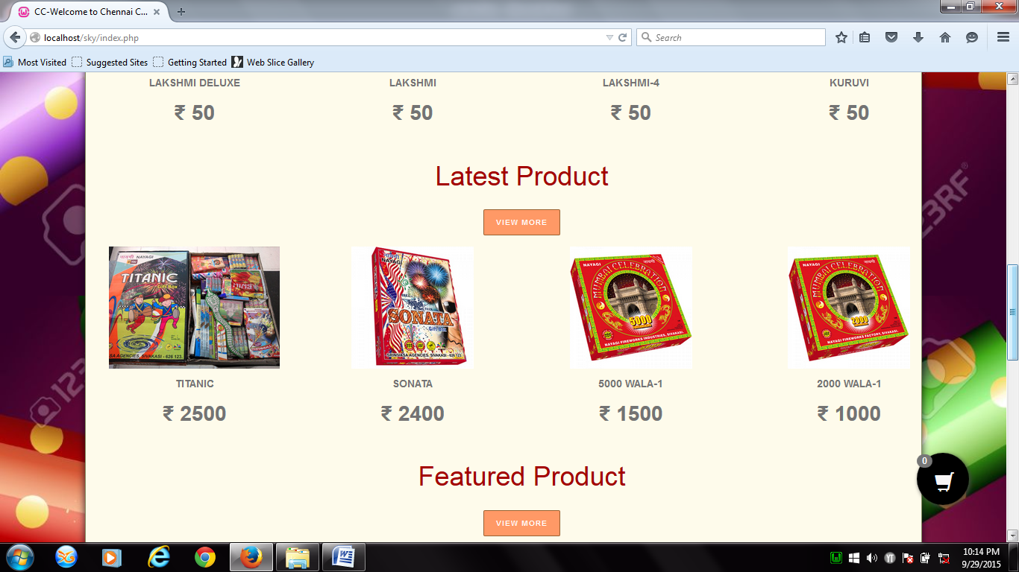

* 1. **LOGIN MODULE:**



* 1. **SIGN UP MODULE:**

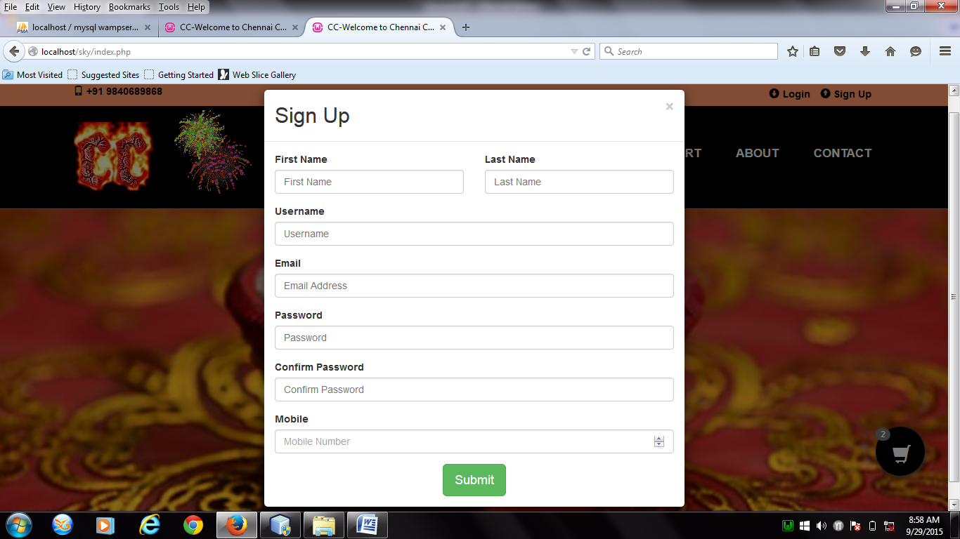

* 1. **ADMIN PANEL:**

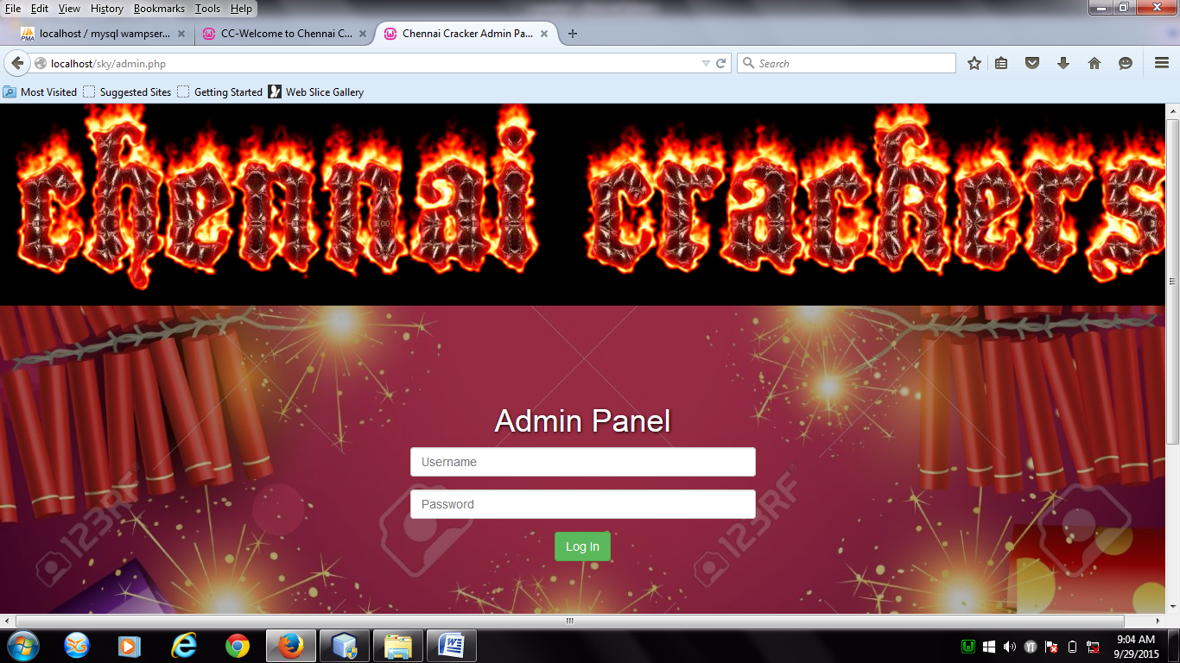

* 1. **INSERT NEW CRACKER:**

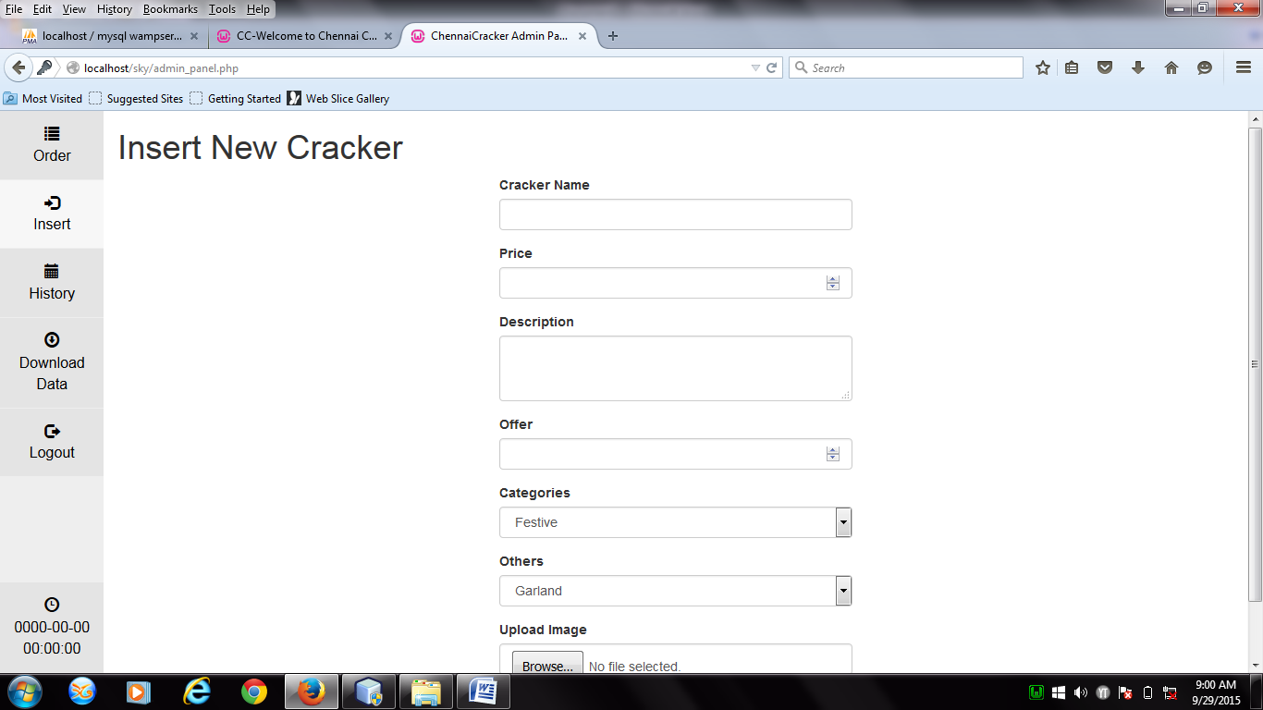

* 1. **CATEGORIES MODULE:**

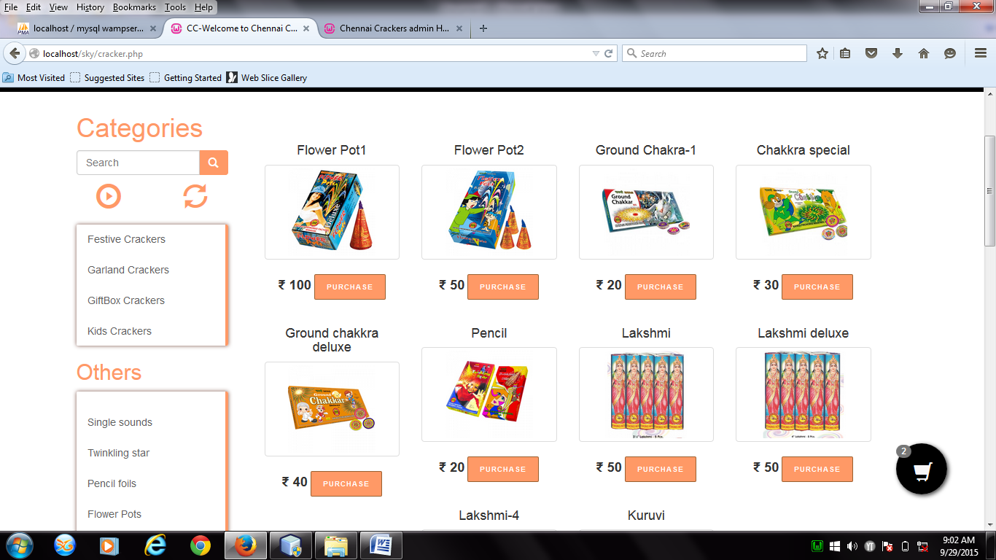

* 1. **PURCHASE MODULE:**

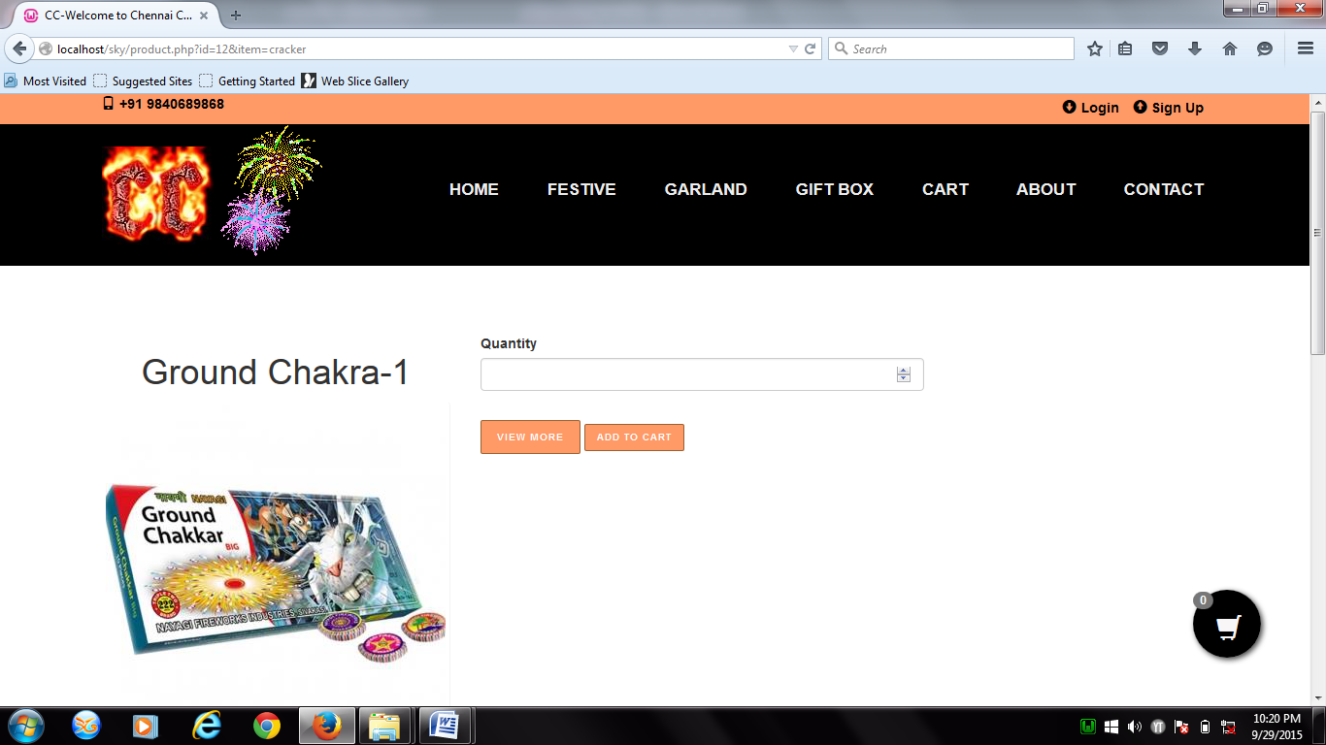

* 1. **ADD TO CART MODULE:**

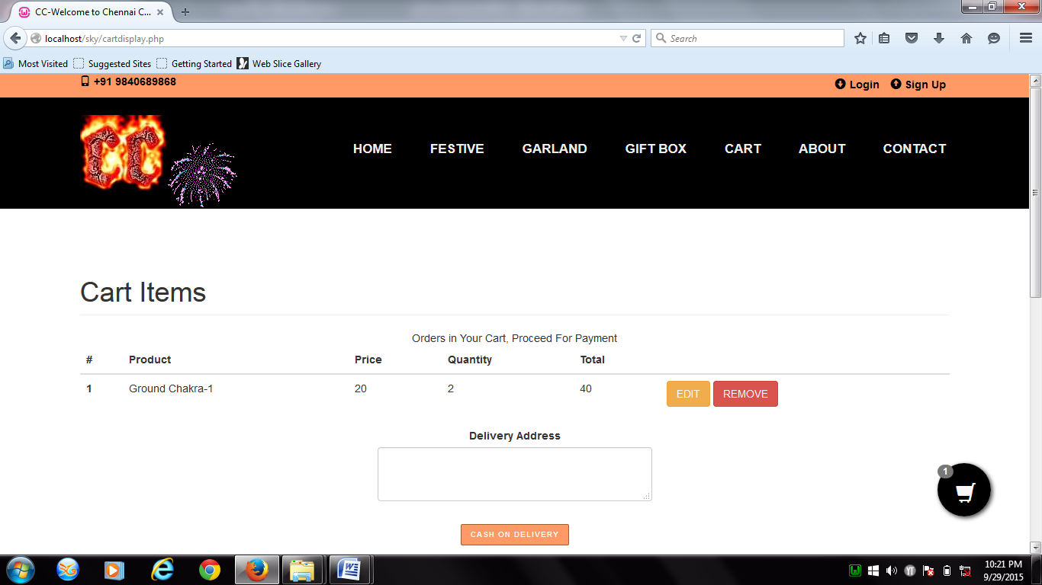

1. **REFERENCES**

a) http://encyclopedia.laborlawtalk.com/IIS for information on IIS

b) http://aspnet.4guysfromrolla.com/articles/020404-1.aspx for relationship between IIS and ASP.NET. 14.

c)http://216.15.201.66/dpec/course.htm?fullpg=http%3A//216.15.201.66/dpec/courses 312/wah006.htm&acro=wac312 for security authentication in ASP.NET 15.

1. http://samples.gotdotnet.com/quickstart/aspplus/doc/mtstransactions.aspx for information on Transactions in ASP.NET.
2. http://www.x-cart.com/articles/design_development.html for online customer behavior.
3. http://aspnet.4guysfromrolla.com/articles/011404-1.aspx for relation between IIS and ASP.NET.
4. Walter Alberto Aldana.” Data Mining Industry: Emerging Trends and New Opportunities”, May 2000.
5. G. Adomavicius and A. Tuzhilin, “Toward the Next Generation of Recommender Systems: A Survey of the State -of-the-Art and Possible Extensions,” IEEE Trans. Knowledge and Data Eng., vol. 17, no. 6, pp. 734 -749, June 2005.
6. Sotiris Kotsiantis, Dimitris Kanellopouios “Association Rules Mining: A RecentOverview” GESTS International Transactions on Computer Science and Engineering, Vol.32 (1), 2006
7. E.W.T. Ngai, Li Xiu and D.C.K. Chau, “Application of data mining techniques in customer relationship management: A literature review and classification” Department of Management and Marketing, The Hong Kong Polytechnic University, Hong Kong, PR China, Department of Automation, Tsinghua University, Beijing, PR China